Simulator Project

# Description and Goals

This project aims to simulate pharmaceutical supply chains in a low- or middle-income country (LMIC) that are subject to insertions of substandard and/or falsified products (hereby referred to as “falsified” products). The supply chain of a single pharmaceutical product (e.g., amoxicillin) is characterized through a network of nodes and arcs, where falsifier product originates from a single falsifier source node. Entities such as importers or outlets may possibly obtain product from these falsifier nodes under different circumstances or configurations. Drug regulatory agencies (DRAs) have the ability to sample and test products from different entities according to testing policies and procurement budgets.

The general aim of this project is summarized as follows: “Under what types of network configurations and falsification contexts can different testing policies most ably detect the underlying structures of falsification?” Falsification structures need to be ascertained using the following pieces of information:

* Sample collection results
  + Importer name
  + Batch in-country arrival date
  + Pass/Fail diagnostic reading
* Reports of stockouts at different entities – either when arriving to collect a sample, or by other means

Summarily, this project will explore some of the following questions:

* Can the location of “bad actors” be detected in the network, and with what degree of confidence? Under what circumstances?
* How do the testing data appear under temporal network changes, i.e., the occurrence of unfit batches of a product that is otherwise fit for consumption?
* What happens as the network expands/contracts in complexity?
* Which testing policies are most/least effective?

# Simulation Model Schematic

The following graphics depict the different structural logic of each element of the simulation.

## Overview of the flow of products (“Drug Packets”)

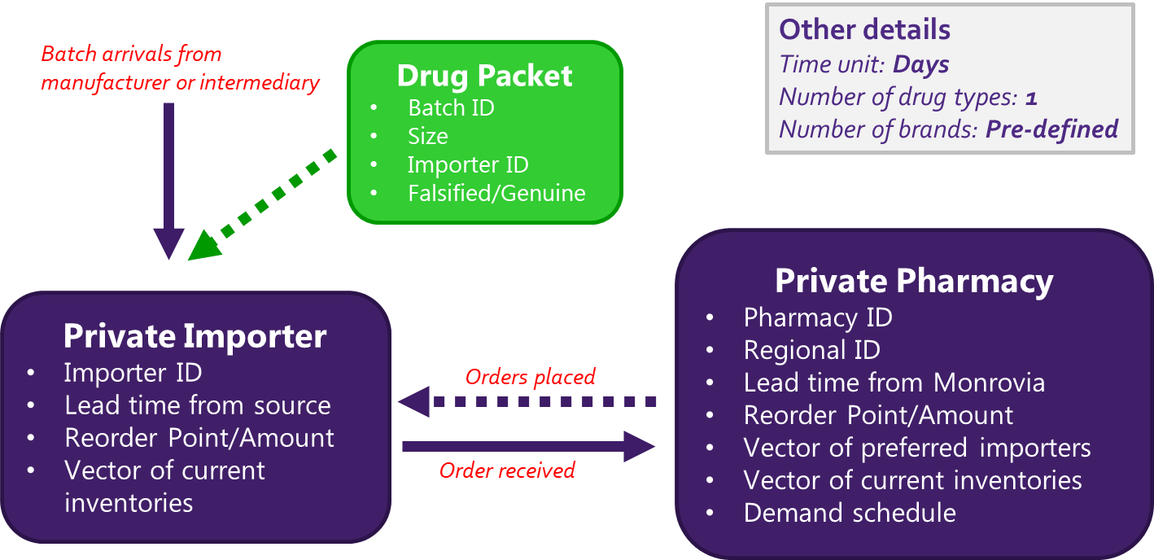

## Timeline at the pharmacy outlet (end node) level

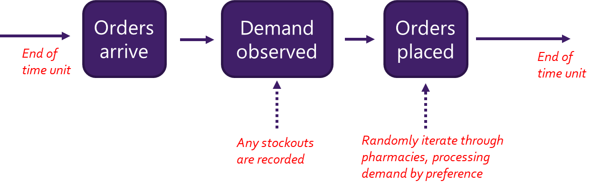

## Model Parameters

The following is a list of parameters that can be modified within the model:

* Reorder points/amount for different entities (i.e., internal policies)
* Lead times and global stockout rates (i.e. external factors)
* Underlying network structures
  + Number of importers that can be accessed by each outlet
  + Number of entities engaging with the falsifier node
  + Overall size/complexity
* Trigger sensitivities for entities opting to source from the falsifier node
* Testing policies and budgets

# Moving Forward

The project will progress under the following steps:

1. Identify some base models and look at different output patterns
2. *[To be discussed]*
3. …

# To-Do’s

*A list of items to complete:*

1. Add warm-up period
   * Have multiple (100?) long warm-up periods that we sample from for each replication (as opposed to generating warm-up periods each time)
2. Put a smaller falsifier “order” amount in the “root” section of the ‘MakeOrder’ method
   * Should be triggered by the ‘current supplier’ node having the ‘FALSIFIER’ label
   * Potentially triggered by the current number of days stocked out, as well
   * Order amount is r/2
   * Record the number of triggers activated per entity
3. Run multiple replications as opposed to long-run simulations
4. Generate ability to run batch files that vary different parameters
5. Put the “batch consumption rate” statistics in the simulation output
6. Streamline testing/sampling process into its own module
7. Implement "sandy" checks to ensure things are running smoothly without errors, outliers, etc.
8. Generate a “scratch folder”